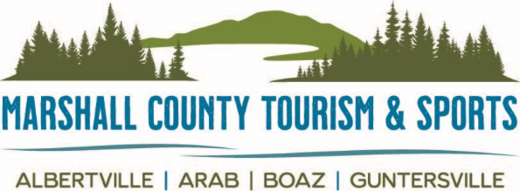

September 9, 2021 FOR MORE INFORMATION:
256-582-7015

Community Paddle Event To Be Held at Sunset Drive

Guntersville, Ala. – The City of Guntersville will host “Paddle Y’all” a free community paddle event at the beach on Sunset Drive, Saturday, September 18 from 10 a.m. to 1 p.m. Everyone is welcome from the beginners to the advanced paddlers. Bring your kayak, canoe or paddle board and join us for this fun day on the water.

Paddle Y’all is the perfect way to get out in a kayak along Lake Guntersville. We will have several experienced paddlers onsite to offer quick lessons, and kayaks will be available for those without one. Paddle along the shoreline, enjoy the outdoors and hear a little information about the history of the lake.

Enjoy music, a free hotdog and chips and a little paddling fun. There will also be an opportunity for those who paddle to register to win a free kayak. The free paddle event is one of several paddling events being held along the Tennessee River as part of the Tennessee Riverline Program. Guntersville was selected as a Rivertown Community in 2020 and one of the goals of the program is to encourage people to enjoy the water through paddling and boating.

The vision of the Tennessee Riverline is to provide one continuous system of paddling, hiking and biking along the Tennessee River’s 652-mile reach. This transformative initiative is led by the University of Tennessee, Knoxville, in collaboration with the Tennessee RiverLine Partnership. River communities that are invested as part of the Tennessee RiverLine benefit from economic development and entrepreneurship opportunities, quality of life amenities and increased access to river experiences that improve public health and generations of river advocates that are active participants in its stewardship.
To learn more about the Tennessee RiverLine, stay updated with programs and initiatives by following on Facebook, Twitter and Instagram (@tnriverline) and visiting tnriverline.org frequently.
###

